Sprint boot MVC Application:

**Postman Request & Response of Product Api’s**

**Create API:**

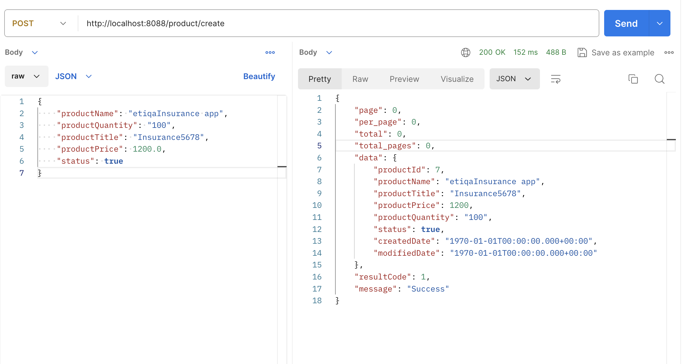

**Update API:**

**Delete API:**

**Get API:**

**Postman Request & Response of Customer Api’s**

**Create API:**

**Update API’s:**

**Delete API:**

**Get API:**

**Swagger API documentation:**

**Project Structure:**

**Test Case Results:**

